# Reaction Time Position Digits (RTPD)

# Introduction

This experiment explores motor skill learning. Motor learning involves implicit memory, and thus participants may improve their performance on a motor related task without being consciously aware (Radvansky & Ashcraft, 2014).

The experimental paradigm used is inspired by serial reaction time tasks (Ashby and O’Brien, 2005). Studies have found reaction time (RT) to improve when stimulus sequence is fixed (Ashby and O’Brien, 2005). Findings of this in the data would provide some evidence for implicit learning, and may reflect this involvement of procedural memory or repetition priming (Ashby & O’Brien, 2005; Radvansky & Ashcraft, 2014).

The present experiment involves both position and digit stimuli. It is hypothesised that RTs will be lower for position condition, where on-screen location is consistent with required motor responses (e.g. Barsalou, 2008).

# Method

This experiment included *N* = 218 participants, all psychology students at UCPH. Age and sex differences were not considered.

## Materials

* RTPD task Eprime file
* Questionnaire

## Test procedure

The experiment was computer-based and conducted using an Eprime file. Instructions were shown on-screen.

The experiment consisted of two parts, divided by stimulus type (position or digit). Each condition contained 20 blocks of 24 trials each. Order of conditions varied between participants. In both conditions, every fifth block sequence was random whilst the rest were fixed.

For the position condition, four boxes were shown on screen followed by a sequence of position cues. The participant (P) responded as fast and accurately as possible, deciding which box held the cue, using keys C, V, B, and N following each trial. For the digit condition, a fixation cross was shown followed by a sequence of digit cues (1 through 4), and P responded using the same keys. Left hand middle and index fingers were used for keys C and V, and right hand middle and index fingers were used for keys B and N, respectively. Cues were shown for 500 ms. P was able to take a small break between blocks.

P filled out a midway questionnaire, asking if they had noticed any specific fixed sequence.

# Results

All statistical results were obtained using SPSS. Any RT analyses included correct responses only.

## Learning effects across conditions

Figure 1 shows mean RT by block number, stimulus type, and sequence type, indicating that RT was generally longer for digit than position condition, and generally lower for fixed than for random blocks. Further, it seems that RT decreases rapidly following the first block for both stimulus conditions, suggesting the presence of an early learning phase (Purves et al., 2013).

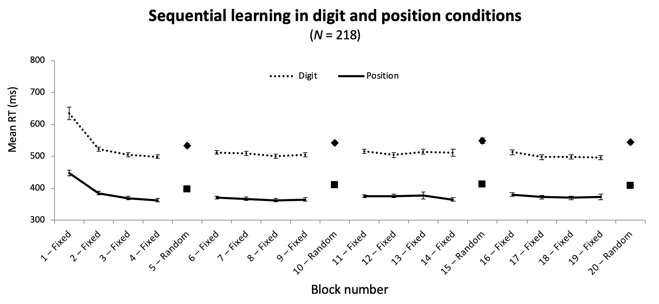

Figure 1: Learning across blocks for digit and position conditions for entire sample.

A repeated measures ANOVA was conducted to test whether such effects on RT were significant in blocks one through four.

The test showed significant main effects of stimulus type, *F*(1.00, 217) = 493.66, *p* < .001, $η_{p}^{2}$ = .70, and block number, *F*(1.27, 276.49) = 91.50, *p* < .001, $η_{p}^{2}$ = .30 (Huyhn-Feldt corrected), and a significant interaction between these, *F*(1.36, 294.76) = 5.96, *p* = .01, $η_{p}^{2}$ = .03.

This means RT varied significantly between these blocks, likely indicating some learning of the sequence (or the task), see Figure 1. The digit condition demanded significantly longer RTs than the position condition (Figure 1), as expected. The interaction shows that the learning effect differs between the two stimulus conditions.

Figure 2 shows a similar, although less clear, pattern for FP19202, suggesting the effects of stimulus and sequence types are also present at an individual level. However, for the digit condition, FP19202 did perform worse on some fixed blocks than on some random blocks, suggesting that any implicit learning effects may be less dominant in this condition.

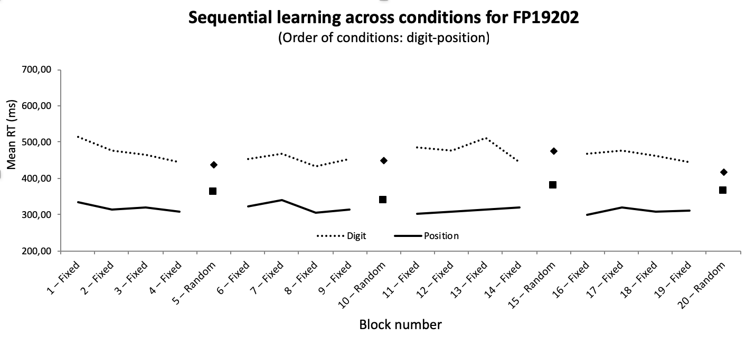

Figure 2: Learning across blocks for digit and position conditions for FP19202.

## Advantage in second condition

Figure 3 displays mean RT across stimulus type and order of conditions.

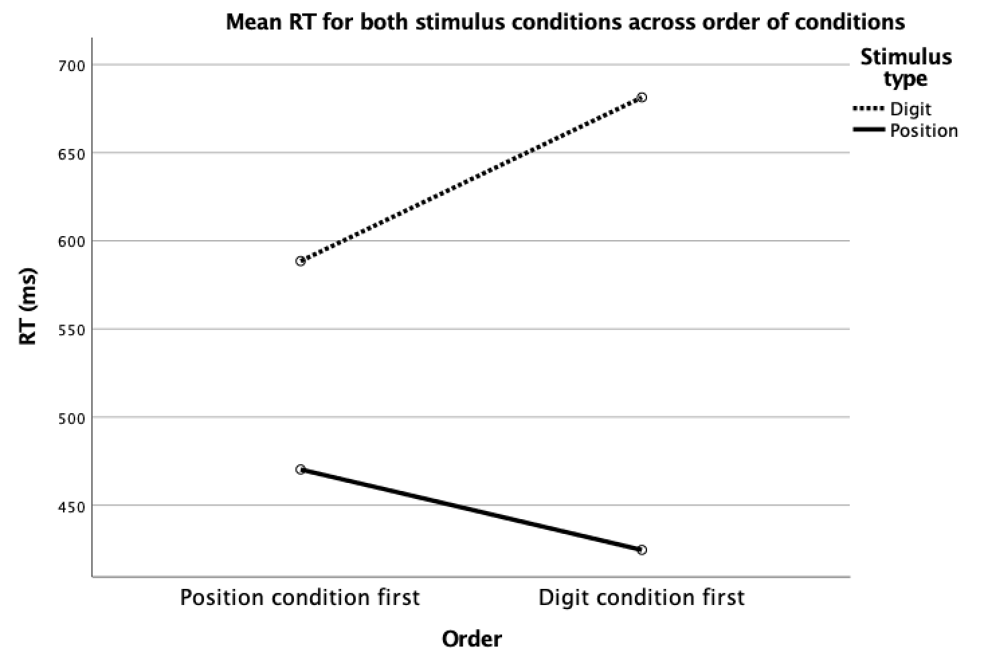

Figure 3: Interaction between stimulus type and order of conditions.

For the first blocks, a repeated measures ANOVA showed a significant main effect of stimulus type, *F*(1, 216) = 97.52, *p* < .001, $η_{p}^{2}$ = .31, and no significant main effect of order on RT, *F*(1, 216) = 1.06, *p* = .31, $η_{p}^{2}$ = .01, but a significant interaction between these, *F*(1, 216) = 13.32, *p* < .001, $η_{p}^{2}$ = .06.

This means RT is longer for digit than position condition no matter which session was conducted first (Figure 3). Figure 3 illustrates the interaction, showing how participants gain a relative advantage in the second condition they perform. This suggests some practice effect.

## Random trials may demand inhibition of implicit memory

For the random blocks, a repeated measures ANOVA showed significant main effects of stimulus type, *F*(1, 217) = 956.99, *p* < .001, $η_{p}^{2}$ = .82, and random block on RT, *F*(2.48, 539.10) = 5.49, *p* = .002, $η_{p}^{2}$ = .03 (Huyhn-Feldt corrected), but no significant interaction between these, *F*(2.67, 578.30) = 0.12, *p* = .93, $η_{p}^{2}$ = .001 (Huyhn-Feldt corrected).

This means the digit condition demanded longer RTs (Figure 1), and that RT varied in between blocks in one condition. However, RT seems to be *longer* for later random blocks (Figure 1), perhaps reflecting a need for inhibiting implicit memory of the fixed sequence.

## Some people are faster than others

A two-tailed Pearson’s correlation showed significant positive correlations between RTs for digit and position conditions in blocks 1 (fixed), *r*(216) = .22, *p* = .001, 19 (fixed), *r*(216) = .30, *p* < .001, and 20 (random), *r*(216) = .54, *p* < .001.

This means participants that responded fast in one condition also responded fast in the other condition throughout the experiment. Further, this correlation is stronger for random trials, suggesting this effect may depend somewhat on individual differences, rather than learning.

## Accuracy is best for fixed trials in position condition

A repeated measures ANOVA showed significant main effects of stimulus type, *F*(1, 217) = 30.26, *p* < .001, $η_{p}^{2}$ = .12, and sequence type on accuracy, *F*(1, 217) = 133.31, *p* < .001, $η_{p}^{2}$ = .38, but no significant interaction them, *F*(1, 217) = 3.10, *p* = .08, $η_{p}^{2}$ = .01.

Thus, participants make significantly fewer errors in the position condition compared to the digit condition, as well as making significantly fewer errors in fixed trials compared to random ones (Figure 4). Further, accuracy is *always* better for fixed trials, regardless of whether these appear in the digit or position condition (Figure 4).

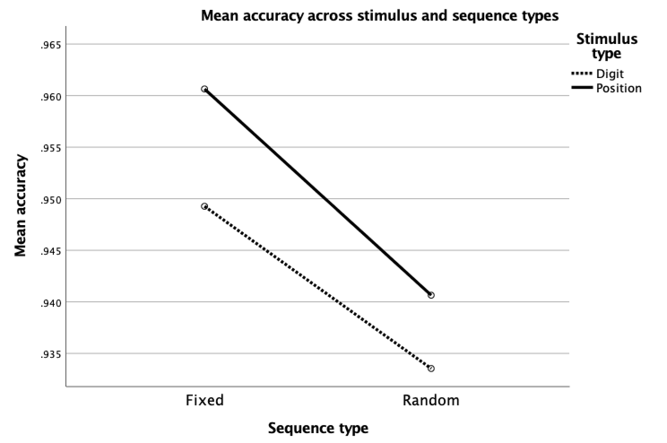

Figure 4: Mean accuracy is better in fixed than in random trials.

## There were speed-accuracy trade-offs

A two-tailed Pearson’s correlation showed significant positive correlations between accuracy and RT for both random digit condition, *r*(216) = .28, *p* < .001, and random position condition, *r*(216) = .36, *p* < .001.

This provides evidence for a speed-accuracy trade-off in both conditions.

# Conclusion

Our data provides evidence for implicit learning of the given motor task. Further, our results suggest that this learning is more effective when the nature of the task corresponds to the required motor response.

# Literature

Ashby, F. G., & O’Brien, J. B. (2005). Category learning and multiple memory sys-

tems. *Trends  in Cognitive Sciences*, *9*, 83-89.

Barsalou, L. W. (2008). Grounded cognition. *Annual review of psychology, 59*, 617-645.

Purves, D., Cabeza, R., Huettel, S. A., LaBar, K. S., Platt, M. L., & Woldorff, M. G.

(2013). *Principles of Cognitive Neuroscience*. (2. udg.). Sunderland.

Radvansky, G. A. & Ashcraft, M. H. (2014). *Cognition*(6. udg.). Pearson Education.